INTRODUCTION

This experiment will allow you to investigate the properties of linear momentum and kinetic energy as applied to one-dimensional collisions.

THEORETICAL BACKGROUND

Linear Momentum, p of an object is defined as the mass, M of an object multiplied by its velocity, v:
$\vec{p}=M \vec{v}$

Kinetic energy for mass, M moving with a velocity, v:
$$K=\frac{1}{2}Mv^{2}$$

Conservation of Linear Momentum

If the net external force acting on the system during a collision is zero then the linear momentum of the system before the collision is equal to the linear momentum of the system after the collision.

$p_{total-initial}= M_{1}{\vec{v}}_{1i}+ M_{2}{\vec{v}}_{2i}$ ……… (1)

$p_{total-final} = M_{1}{\vec{v}}_{1f}+ M_{2}{\vec{v}}_{2f}$ ………. (2)

Hence: $M_{1}{\vec{v}}_{1i}+ M_{2}{\vec{v}}_{2i} = M_{1}{\vec{v}}_{1f}+ M_{2}{\vec{v}}_{2f}$

M₁ = mass of object 1 M₂ = mass of object 2
v_{1i} = initial velocity of M₁ before collision v_{2i} = initial velocity of M₂ before collision
v_{1f} = final velocity of M₁ after collision v_{2f} = final velocity of M₂ after collision

Conservation of Kinetic Energy

Certain collisions are referred to as elastic collisions if the kinetic energy is conserved. These types of collisions can only be approximated in our laboratories.

total kinetic energy before collision = $K_{total-initial}=\frac{1}{2}M_{1}v_{1i}^{2}+ \frac{1}{2}M_{2}v_{2i}^{2}$ ……(3)

total kinetic energy after collision = $K_{total-final}=\frac{1}{2}M_{1}v_{1f}^{2}+ \frac{1}{2}M_{2}v_{2f}^{2}$ …...(4)

Collisions in which kinetic energy is not conserved are called inelastic collisions. In these types of collisions linear momentum is conserved (as long as the net external force on the system is zero). Completely inelastic collisions are those where the objects stay together after the collision.

APPARATUS

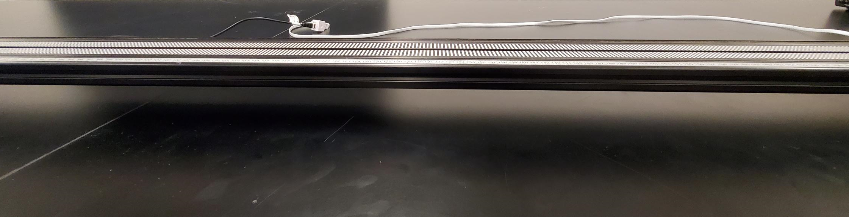

A horizontal track

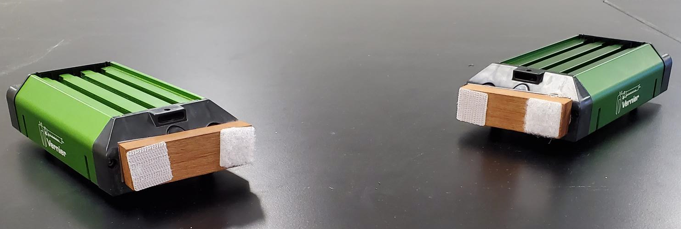
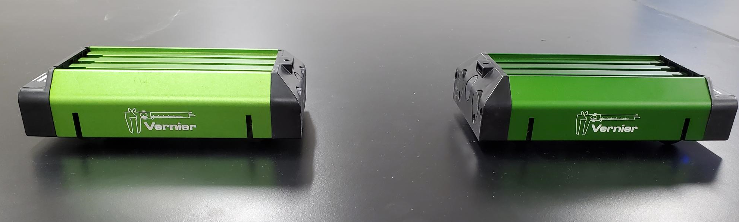

Carts for elastic collision Carts for inelastic collision with Velcro bumps attachment

- A horizontal track.
- When the carts collide, the optical track collects the data as position versus time to give velocities of the carts before and after collision - read as computer graph outputs.
- The two carts need to be marked as M₁ and M₂. Attachments for inelastic collision is as shown.
- For elastic collision, no attachments are needed.
- For inelastic collision, Velcro bumpers are used

MEASUREMENTS, DATA AND ANALYSIS

PART 1 – ELASTIC COLLISION
NOTE:

- Mark with the tape carts M1 and M2
- Turn the “ON” the power button on the carts.
- On your desktop, open the Folder Vernier
open the File Collisions New Track

Case 1-A: M₁ = M₂, with M₁ moving and M₂ stationary
- You need to find the mass of the carts M₁ and M₂ (in kilograms) and record these values in
Data Table 1-A.
- Click “COLLECT” icon, release the cart(s) with an initial velocity.
Make sure the collision between M₁ and M₂ occurs smoothly.
– depending on the case you will get initial and final velocities for both carts.
- Click on the icon “A” – to get auto-scale of the graphs.
- Use the cursor – locate the cursor at the position of initial velocities of the two carts and
record these (v_{1i} and v_{2i}) in the Data Table 1-A.

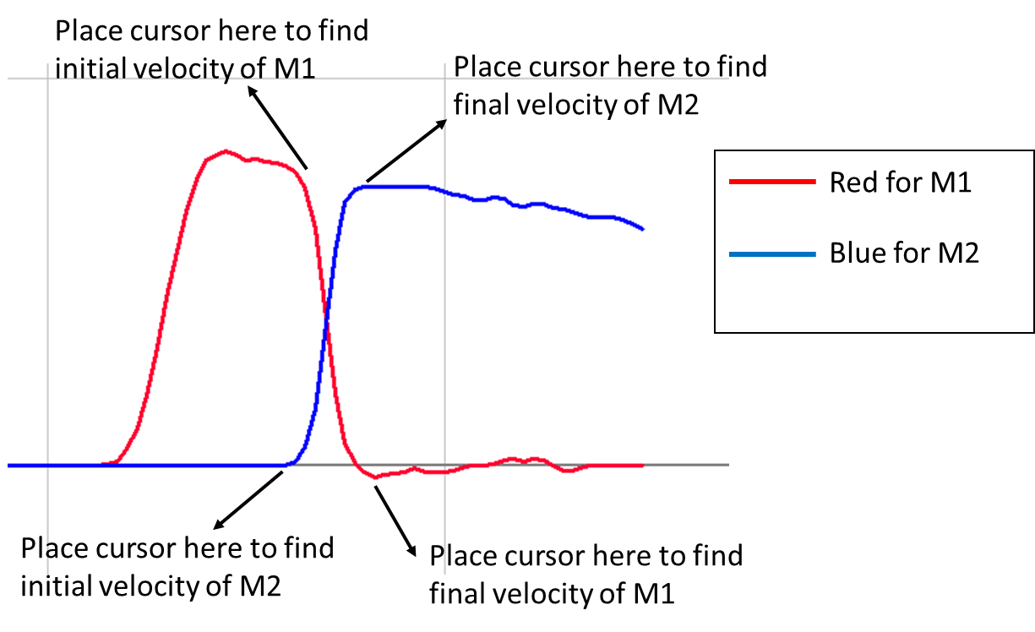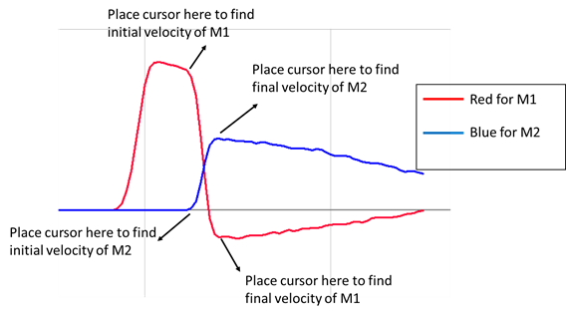

- Similarly locate the cursor at the position of final velocities of the two carts and record
These values (v_{1f} and v_{2f}) in the Data Table 1-A.
- Make sure you correctly note down the direction of the velocity (+ or - )

Case 1-B: M₂ > M₁, with M₁ moving and M₂ stationary
- Add mass to cart-2.
- Repeat steps a to f for the above case and record the data in Data Table 1-B.
- Note the velocities of the carts before and after collision in your Data Table 1-B.
- Make sure you correctly note down the direction of the velocity (+ or - )

Case 1-C: M₁ = M₂, with both M₁ and M₂ moving:
- Remove the added mass from cart-2.
- Repeat steps a to c for the above case.
- From the computer output graph, make an observation of the velocities of the carts before and after collision on. Write down your observations.

For each case –
- Analyze your data performed for part 1 of the experiment and complete the Data Tables 1-A and 1-B.
- Write your observations for case 1-C.

PART 2 – INELASTIC COLLISION

You need to attach the Velcro bumps to the carts for inelastic collision.

Case 2: M₁ = M₂, with M₁ moving and M₂ stationary:
Perform the experiment following the steps a through f.
Note the velocities of the carts before and after collision in your Data table 2-A.
Make sure you correctly note down the direction of the velocity (+ or - )

Analyze your data performed for part 2 of the experiment and complete the Data Table-2.

***** Turn “OFF” the power button on the carts *****

RESULTS AND ANALYSIS
$$Percentage Diff in momentum \%=\frac{\left|p(final)-p(initial) \right|}{p(initial) }*100\%$$
$$Percentage Diff in Kinetic energy \%=\frac{\left|K(final)-K(initial) \right|}{K(initial) }*100\%$$
Part 1: Elastic Collision
- Complete the calculations in Data Table-1A and Data Table-1B.
- For each of the cases – find percentage difference in momentum and kinetic energy.
- Write your observations for the case 1-C.

Part 2: Inelastic Collision
- Complete the calculations in Data Table-2.
- Find percentage difference in momentum and kinetic energy.

Elastic Collision: DATA TABLE 1-A with M₁ = M₂, with M₁ moving and M₂ stationary:
M₁ = ………. kg M₂ = ………..kg

 | Initial velocity (m/s) | Initial Momentum | Final velocity (m/s) | Final Momentum | p_{total-initial}  _{Eq.(1)} | p_{total-final}  _{Eq.(2)} | Percent difference in momentum
Elastic Collision | v_{1i} = | p_{1i} = M₁* v_{1i}  = | v_{1f} = | p_{1f} = M₁* v_{1f}  =
 | v_{2i} = | p_{2i} = M₂ * v_{2i}  = | v_{2f} = | p_{2f} = M₂* v_{2f}  =

 | Initial velocity (m/s) | Initial KE | Final velocity (m/s) | Final KE | K_{total-initial}  _{Eq.(3)} | K_{total-final}  _{Eq.(4)} | Percent difference in Kinetic energy
Elastic Collision | v_{1i} = | K_{1i} = $\frac{1}{2}M_{1}v_{1i}^{2}$  = | v_{1f} = | K_{1f} = $\frac{1}{2}M_{1}v_{1f}^{2}$  =
 | v_{2i} = | K_{2i} = $\frac{1}{2}M_{2}v_{2i}^{2}$  = | v_{2f} = | K_{2f} = $\frac{1}{2}M_{2}v_{2f}^{2}$  =

Elastic Collision: DATA TABLE 1-B with M₂ > M₁, with M₁ moving and M₂ stationary:

M₁ = ……….kg M₂ = ………..kg

 | Initial velocity (m/s) | Initial Momentum | Final velocity (m/s) | Final Momentum | p_{total-initial}  _{Eq.(1)} | p_{total-final}  _{Eq.(2)} | Percent difference in momentum
Elastic Collision | v_{1i} = | p_{1i} = M₁* v_{1i}  = | v_{1f} = | p_{1f} = M₁* v_{1f}  =
 | v_{2i} = | p_{2i} = M₂ * v_{2i}  = | v_{2f} = | p_{2f} = M₂* v_{2f}  =

 | Initial velocity (m/s) | Initial KE | Final velocity (m/s) | Final KE | K_{total-initial}  _{Eq.(3)} | K_{total-final}  _{Eq.(4)} | Percent difference in Kinetic energy
Elastic Collision | v_{1i} = | K_{1i} = $\frac{1}{2}M_{1}v_{1i}^{2}$  = | v_{1f} = | K_{1f} = $\frac{1}{2}M_{1}v_{1f}^{2}$  =
 | v_{2i} = | K_{2i} = $\frac{1}{2}M_{2}v_{2i}^{2}$  = | v_{2f} = | K_{2f} = $\frac{1}{2}M_{2}v_{2f}^{2}$  =

Inelastic Collision: DATA TABLE 2 with M₁ = M₂, with M₁ moving and M₂ stationary:

M₁ = ……….kg M₂ = ………..kg

 | Initial velocity (m/s) | Initial Momentum | Final velocity (m/s) | Final Momentum | p_{total-initial}  _{Eq.(1)} | p_{total-final}  _{Eq.(2)} | Percent difference in momentum
Inelastic Collision | v_{1i} = | p_{1i} = M₁* v_{1i}  = | v_{1f} = | p_{1f} = M₁* v_{1f}  =
 | v_{2i} = | p_{2i} = M₂ * v_{2i}  = | v_{2f} = | p_{2f} = M₂* v_{2f}  =

 | Initial velocity (m/s) | Initial KE | Final velocity (m/s) | Final KE | K_{total-initial}  _{Eq.(3)} | K_{total-final}  _{Eq.(4)} | Percent difference in Kinetic energy
Inelastic Collision | v_{1i} = | K_{1i} = $\frac{1}{2}M_{1}v_{1i}^{2}$  = | v_{1f} = | K_{1f} = $\frac{1}{2}M_{1}v_{1f}^{2}$  =
 | v_{2i} = | K_{2i} = $\frac{1}{2}M_{2}v_{2i}^{2}$  = | v_{2f} = | K_{2f} = $\frac{1}{2}M_{2}v_{2f}^{2}$  =

LAB REPORT:

You may submit your abbreviated lab report in Gradescope by the end of the lab period, but the latest that it can be submitted is 11:59 p.m. of the day you do the experiment.

- Use the template to write the lab report.
- Include your data tables, short results/analysis and discussion section.
- Convert your lab report from word to pdf file.
- Upload your lab report to Gradescope – before you leave the lab, if possible.

Lab report – 50 points (Maximum)

……..See next page for lab report template and rubric……..

Physics I - Lab 6 Report – One-Dimensional Collisions

Your Name:

Lab Section:

Lab date:

- Objective. (5 points)

- Part 1 - Result and Analysis (10 points)
- Part 1A and 1B - For elastic collision – Complete the data tables 1A and 1B. You can use the Excel to create this and include in the report.
- Part 1C - Write your observations of the velocities of the carts before and after collision.

- Part 1 – Discussion (10 points)
- Part 1A and 1B - For elastic collision - Is total momentum of the system conserved? Explain your reasoning.
- Is the kinetic energy of the system conserved? Explain your reasoning.
- Part 1C – Discuss your observations of the velocities of the carts before and after collision.

- Part 2 - Result and Analysis (10 points)
- For inelastic collision – Complete the data table 2. You can use the Excel to create this and include in the report.
- Part 2 – Discussion (10 points)
- For inelastic collision - Is total momentum of the system conserved? Explain your reasoning.
- Is the kinetic energy of the system conserved? Explain your reasoning.

- Conclusion (5 points)

